**SMART PARKING SYSTEM**

**LBS-523-20**

**Completed by: PARSHITA KHANDELWAL**

**Problem Statement:**

1.  Issue- As the population has been increased tremendously the  vehicular traffic and its parking has been an issue of great concern. In public places where there are many visitors,there is much time wastage for searching parking slots. Also much manual work is needed for this.

2.  Vision-There should be an automatic parking system which will be safe, speedy, user friendly and cost effective. There should be simultaneously operations on different floors for car parking.

3. Method- This project is our attempt to make a fully automatic vehicle parking system.

**Abstract:**

This project aims to automate vehicle parking system. It is an IOT based project in which a car is sensed during entry and exit and accordingly parking slots are allotted depending on vacancy. The automatic vehicle parking system is made using STM32FC103 microcontroller. When the vehicle will arrive in front of the gate, it will be sensed by ultrasonic sensor and the gate will open with the help of servo motor. The parking system will have a specific capacity for vehicles. If the capacity is full the gate will not open. This is done by a counter which wil increase when a vehicle will enter and decrease when a vehicle will exit.This system has a capacity of 15 vehicles. Also the camera helps to differentiate between cars, bikes and SUVs. According to size the LCD displays the slot for the vehicle. Booking can be done on the app.

**Implementation:**

Software:

1. Arduinio IDE : It has been used in which a program consisting of various instructions to the ultrasonic sensor and servo motor have been written. It also includes counter which increments and decrements on arrival and exit of a vehicle.

2.Thunkable classic for Android Development

Hardware:

1. STM32FC103 microcontroller

The arduino program is compiled, run and stored in this microcontroller. The system starts working when the power is switched on.

2. Ultrasonic Sensor

It sends transmittng signal and receives the signal. Thus it is used to detect a vehicle by specifying the distance.

3. Servo Motor

When the vehicle is detected and if the capacity isn’t full then the servo motor will rotate to 90 degrees. After the vehicle moves in it will again come to 0 degrees.

4. LCD Display

It displays slot no which are empty.

5. Camera

It categorizes vehicles according to sizes using image processing.

**BLOCK DIAGRAM**:

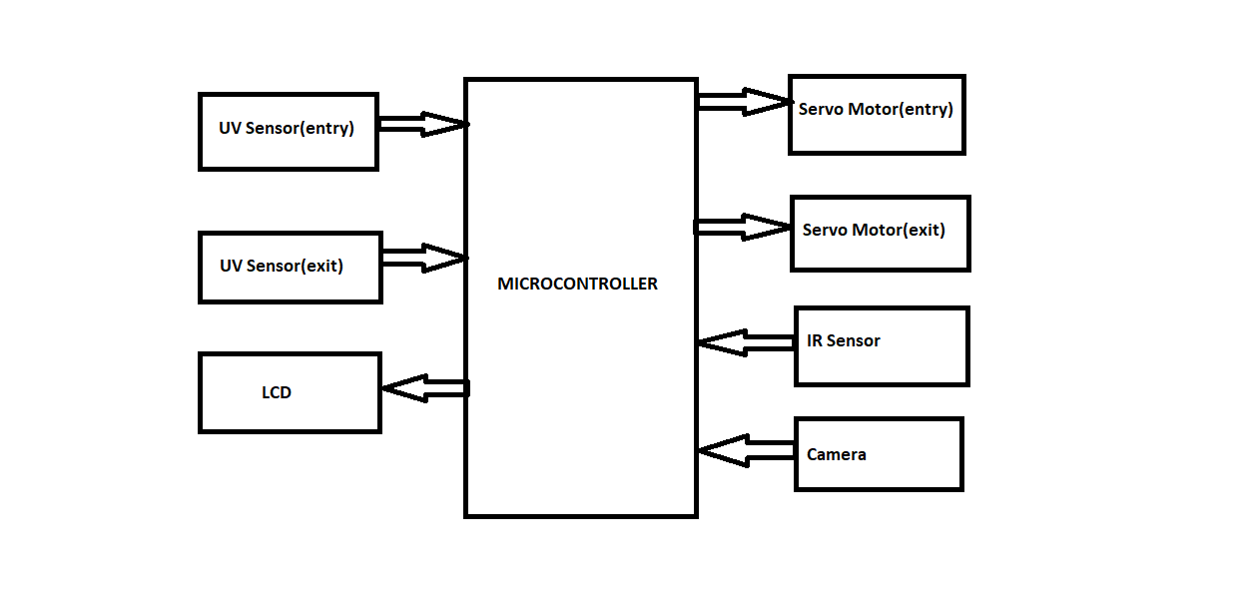

**Applications:**

1. Offices

2. Malls

3. Hospitals

4. Amusement parks